Security Architecture Review

System Overview
- What is the system name?
eStoreCommon App: As part of new initiatives within the eStore Common App (eCA), the FNB team will develop new components in-house. These components will extend the existing eCA platform to support both new and existing functionalities. This request is to build the QA, Staging and Prod environment based on approved SAR for development environment.

- Provide a description of the system and what it does.
The system consists of new in-house components developed and hosted on FNB infrastructure as an extension of the eStore Common App (eCA). These components support end-to-end functionality for the Mortgage Customer Application, Mortgage Loan Officer workflows, and in-branch applications used by FNB bankers.

The system enables seamless interaction between internal applications and external systems through secure inbound and outbound integrations, ensuring efficient data exchange and consistent user experiences across mortgage-related channels.
The system integrates with the existing eStore Common App (eCA) platform built on Temenos, which serves as the foundational application. In addition, the following tomcat will be built and deployed on FNB infrastructure:
- Standalone Banker Applications:
Banker-facing components will be developed and deployed as independent, standalone applications outside of the core eCA platform and deployed on FNB infrastructure.
- Authentication and Single Sign-On (SSO):
Banker applications will leverage Single Sign-On (SSO) enabled through a custom authentication service; this is service is going to be deployed to FNB infrastructure.
- Integration Dependencies:
The system will rely on secure REST-based integrations between eCA, the standalone banker applications, and supporting services to enable seamless functionality across platforms.
Banker and internal user-facing components will not be available over the internet. To access the banker functions internal users, have to be on FNB network.
All inbound requests, whether originating from internal networks or external sources are authenticated and authorized using industry-standard OpenID Connect (OIDC) and OAuth 2.0 protocols at the API Gateway layer. The API Gateway serves as the central enforcement point, integrating directly with the custom Authentication Service to validate user identity, token integrity, token expiry, scopes, and authorization claims before any request is permitted to reach downstream services.
Only requests with valid OIDC ID tokens and OAuth 2.0 Access Tokens are allowed to proceed. All unauthorized, expired, tampered, or malformed tokens are rejected at the edge, ensuring no unauthenticated traffic enters the internal trust service network.

The newly provisioned on‑prem infrastructure supports both the Mortgage and In‑Branch Console‑less initiatives for the eStore Common App. All UI components, APIs, and supporting services for these capabilities will be developed internally and deployed within FNB’s on‑premise environment. The sections below outline the end‑to‑end flow for each Mortgage module.

Mortgage Application Flow
The Mortgage solution consists of two distinct modules:
- Borrower View – Customer-facing micro-application
- Loan Officer View – Internal application for FNB Mortgage staff
Both modules operate independently and enforce their own authentication and authorization controls.
1. Borrower View (Customer-Facing)
When an FNB customer selects Mortgage Product from eStore and starts applying for it from the eStore Common App, they are directed to the Mortgage Borrower view. This interface collects all information required to submit a mortgage application. The UI and backend APIs for this module will be fully hosted on FNB’s on-prem infrastructure.
Integration with Temenos Journey Manager (TJM)
The Borrower View is deployed as a Micro-Application. TJM integrates with it through the following secure sequence:
- Customer initiates a Mortgage application in eStore.
- TJM calls the FNB Auth API using a Client ID and Secret to obtain a secure token.
- The Auth API validates:
  - The request originates from an approved whitelisted IP range
  - Credentials are valid
- Upon successful validation, the Auth API issues an encrypted JWT to TJM.
- TJM uses this JWT to load the Borrower micro-app hosted on FNB infrastructure.
- The micro-app and its backend APIs validate the JWT on every request to ensure the request is legitimate and originates from TJM.
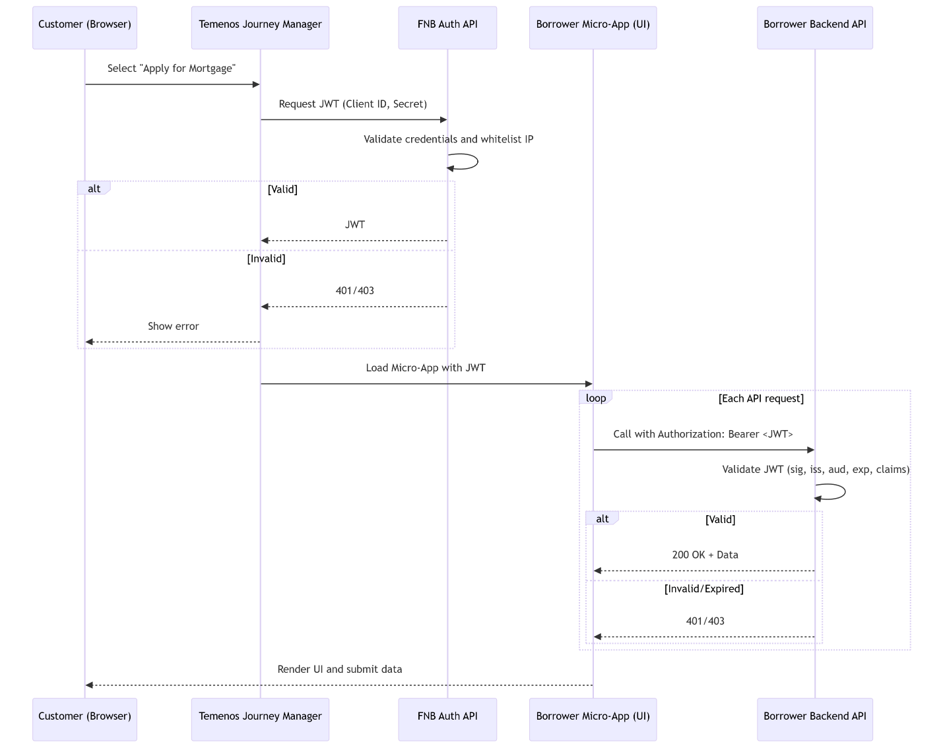
The backend APIs after validating the authenticity of the request will provide following functions:
"API Rate limiting will not be implemented here. There is not external consumer API calls. The API calls are from our own apps.
- Accept details enter by the customer and store those to database
- Provide Asset and employment verification using third party integrations
- Pre-fill some details in case of existing customers
- Submit the mortgage application
- Write Logs and audit information to database
2. Loan Officer View (Internal FNB Application)
The Loan Officer View is a standalone application that serves as the working console for the FNB Mortgage team. It is separate from Borrower View and is accessible only to FNB employees who have the correct Loan Officer AD group assigned.
The UI and supporting APIs for this module are also deployed entirely on-prem.
Authentication & Authorization (SSO via Entra ID)
The Loan Officer application uses Standard OIDC/OAuth 2.0 with Microsoft Entra ID as the identity provider.
The authentication sequence is as follows:
- The Loan Officer accesses the SSO link for Loan Officer view.
- Microsoft Entra ID authenticates the user and issues a secure JWT back to the UI application.
- The UI includes this JWT in each API call.
- Backend APIs validate the token every request, every time, ensuring:
  - The user is authenticated
  - The token is valid and unexpired
  - The user belongs to the required Loan Officer AD group
Only after these validations are passed can the Loan Officer access or modify mortgage application data.

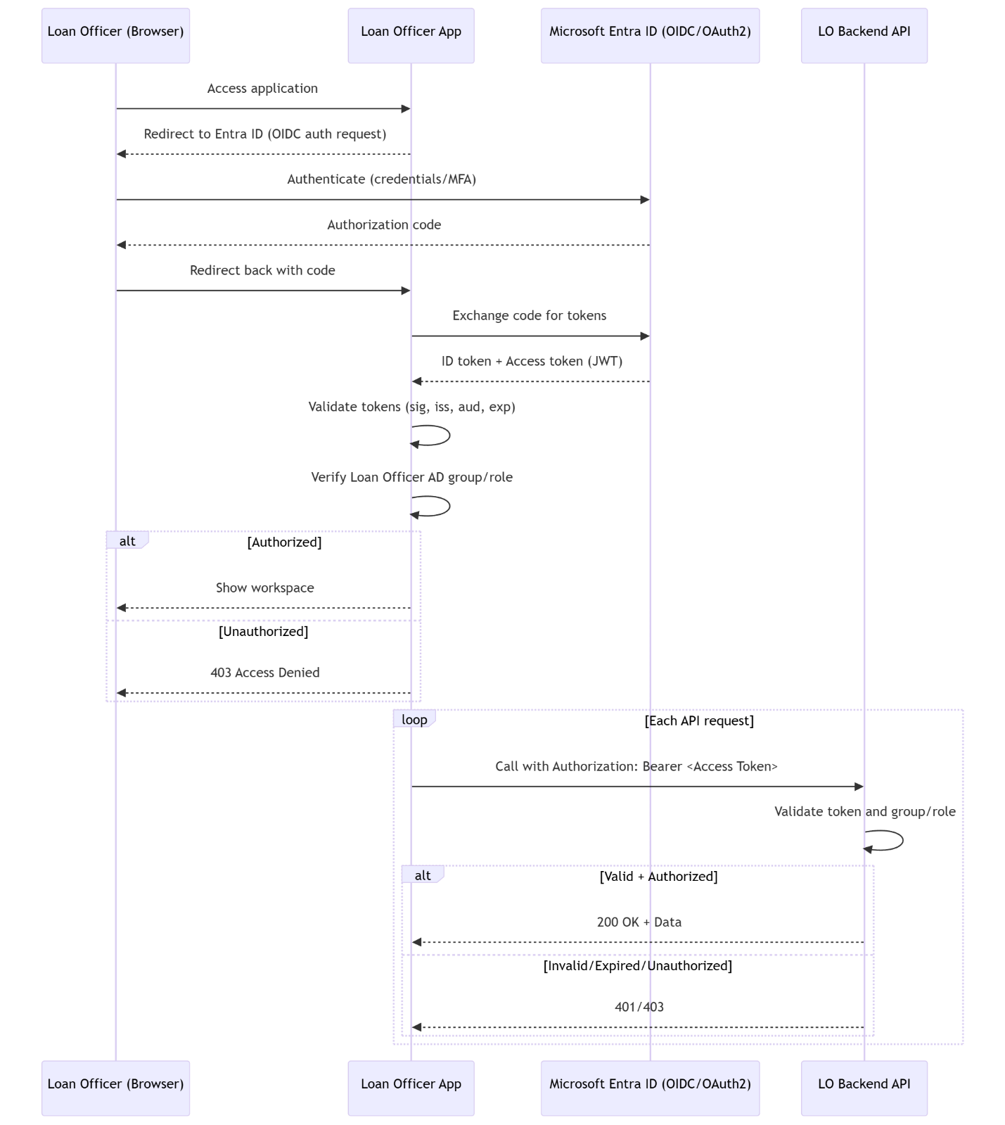
The backend APIs after validating the authenticity of the request will provide following functions:
- Review and update information entered the customers
- Invite a customer to fill in the application or fill the application on customers behalf
- Multiple vendor integration to pull credits, validate asset and income, get mortgage rates, calculate cost etc..
- Request more information or documents (FNB Document center integration)
- Submit mortgage to loan origination system

In-Branch Console less Flow
In-Branch Console less is standalone internal FNB banker facing application. Banker application follows the same authentication flow for internal user as Mortgage Loan Officer view. This application will be accessed by the FNB branch banker, video banker and mortgage banker. New AD groups will be created for each of these different roles.
The In-Branch Console-less application is a standalone, internal, banker-facing solution. It uses the same SSO authentication and authorization flow as the Mortgage Loan Officer View, leveraging Microsoft Entra ID (OIDC/OAuth 2.0) for secure access.
This application will be used by three internal roles:
- FNB Branch Banker
- FNB Video Banker
- FNB Mortgage Banker
Dedicated Active Directory groups will be created for each role. Access to the application and its backend APIs will be governed by these groups, ensuring that users can only access functionality aligned with their assigned role.
In addition:
- Each service layer performs secondary validation to ensure the request originates from a trusted gateway and from a legitimate, expected client identity.
- Zero Trust principles are applied at every hop - no service implicitly trusts upstream components, and every interaction is explicitly authenticated and authorized.
- Resource APIs revalidate tokens or signed internal service credentials to prevent spoofing, replay attacks, or lateral movement within the system.
Our application uses a multi-layer API structure, and each layer is responsible for validating the request on its own. No layer automatically trusts another layer. This approach follows Zero Trust principles, meaning every request is checked every time, no matter where it comes from.
The flow works like this:
- Gateway Layer
This is the first point of entry. It checks whether the request is genuine by validating the JWT. Only valid requests move forward.
- Experience Layer
Even though the request came through the gateway, the experience layer still performs its own validation. It re-checks the JWT—signature, issuer, audience, expiration, and claims. After validating the request again, this layer handles UI needs and then calls the core services.
- Core Processing Layer
Core APIs also repeat the validation steps before running any business logic. They verify the token again to ensure the caller is legitimate and allowed to perform the action.
By validating tokens at every step, the system protects against issues like spoofing, replay attacks, or someone trying to move deeper into the system after gaining access to a lower layer. If one layer is compromised, the attacker cannot automatically reach other layers because each one has its own independent validation.

- High Level component diagram: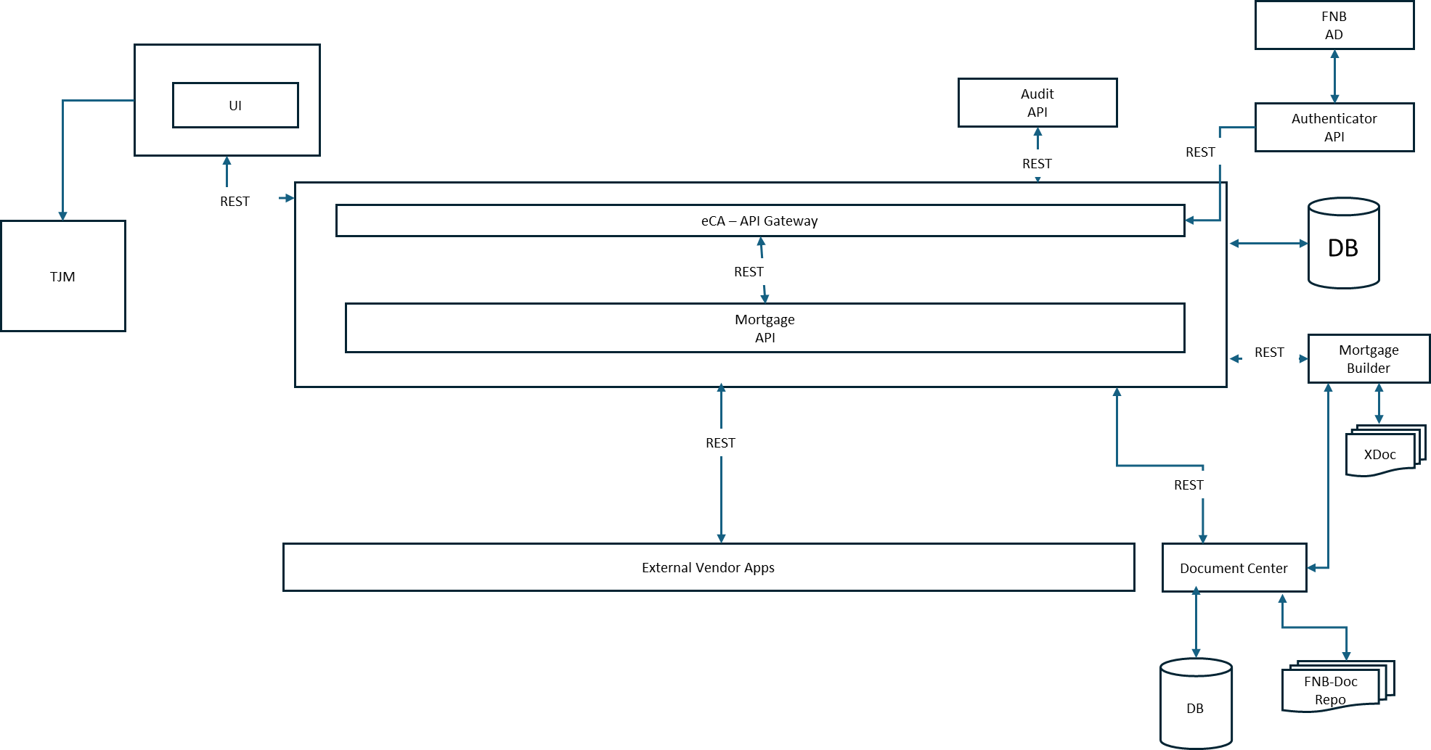

- The API Gateway layer is a software layer (API), will be installed on DMZ server. The purpose of this API is to validate the request source and legitimacy of the request before it can be passed to processing layer. This layer is not intended to bypass any other security layer which FBN may have.

- Is this a new software implementation or a software upgrade?
This initiative represents a software upgrade and enhancement to the existing eStore Common App (eCA) and Document Center platforms. New components will be integrated into these systems using a micro-frontend architecture, where UI elements are injected as reusable web components.
All non-UI interactions will be handled through secure REST API communication over port 443, enabling seamless integration between internal components and external systems while leveraging the existing application ecosystem.
In short it a both upgrade and new implementation.

- Are servers being installed or replaced as part of this project?
Yes, this is a request for new servers for Dev, QA, Staging and Prod. Development environment is already built as per below configuration.

Dev (already built)

Trust – 5 (1 each for corresponding TJM organization, there are 5 organizations in TJM) RHEL for UI – will run web application UI on port 443
Trust – 5 (1 each for corresponding TJM organization, there are 5 organizations in TJM) RHEL for API – will run REST APIs on port 443
1 SQL Server Database with 5 different schemas installed on it.

- ECA Approved SAR Diagram - Infra-Provisioning.vsdx

QA (Already built)

Trust – 5 (1 each for corresponding TJM organization, there are 5 organizations in TJM) RHEL for UI – will run web application UI on port 443
Trust – 5 (1 each for corresponding TJM organization, there are 5 organizations in TJM) RHEL for API – will run REST APIs on port 443
1 SQL Server Database with 5 different schemas installed on it.

Staging (already built)

Trust – 10 (2 each for corresponding TJM organization, there are 5 organizations in TJM) RHEL for UI – will run web application UI on port 443
Trust – 10 (2 each for corresponding TJM organization, there are 5 organizations in TJM) RHEL for API – will run REST APIs on port 443
1 SQL Server Database with 5 different schemas installed on it.

Prod (To be built)

Trust – 4 Server Cluster RHEL will run web application UI on port 443
Trust – 4 Server Cluster RHEL for API – will run REST APIs on port 443
1 SQL Server Database

- Has all licensing been reviewed by IT Service Quality (ITAM)?

In-house, no. This request is for provisioning new servers.

Architecture and Integration
- What are the software requirements and dependencies for the system? List all software (including versions) that is not part of our base system builds.
Java 21 or Java 25, Nginx 1.28.2 or Apache 2.4, Apache Tomcat 11.x, SQL Server 2022, RHEL 10.1 (LTS)

- Is this solution deployed internally, hosted in the cloud, or implemented as a hybrid with both cloud and on-premises components? If there are cloud components, please specify the hosting provider (ex: AWS, GCP, OCP, Microsoft Azure) and the geographic regions FNB instance will reside in. Additionally, provide a detailed breakdown of the application stack within the cloud environment (Application Server, Web Server, Database Server, etc.). This needs to be incorporated into the diagram.
- New components will be developed in-house and installed on-prem.
- Existing TJM components are installed on AWS cloud.

- Is there vendor provided hardware or virtual images associated with this system?
No
- Does this system have a web interface that external bank customers authenticate into? If yes, will they access a vendor hosted web servers, or a web server hosted in FNB’s DMZ?
This application will have web pages which will be accessed by external customers, the user authentication is happening via Temenos Journey Manager (TJM) and will remain as it is with this change.

Authentication will remain same for external customers as request will be initiated from the Temenos Journey Manager platform.
For FNB employee’s banker facing functionality will not go through Temenos Journey Manager. The authentication and authorization will be done using industry standard OIDC and oAuth 2.0 workflow provided by Microsoft Entra ID. The detailed flow is explained in earlier section.

- Provide a detailed technical network diagram of the solution.

- Provide a detailed listing of Firewall rule changes required with this design, including Windows OS firewall.
The new FNB hosted components will have connectivity with external vendor applications over REST based web services.

Following firewall rules will need to be established:
Trust F5 Load Balancer to REHL UI Server on Port 443
Trust F5 Load Balancer to REHL API Server on Port 443
REHL DMZ Server to Trust F5 Load Balancer (DMZ to Internal) on Port 443
Trust F5 Load Balancer (DMZ to Internal) to REHL UI Server on Port 443
Trust F5 Load Balancer (DMZ to Internal) to REHL API Server on Port 443
REHL API Server to Database Server on Port 1433
REHL API Server to Pdcoawebdev01 (COA servers on corresponding environment) on Port 5575
REHL API Server to PDADOWEBPRD01/ PDADOAPPPRD02 on Port 443
RHEL API Server (build) to jfrog/code artifactory url on port 443
RHEL API Server (build) to maven/npm central repository url on port 443

- List all network ports, protocols, and security ciphers the application uses to function or integrate with other systems.
The new FNB hosted components will have connectivity with external vendor applications over REST based web services.
For example the external webservices are Plaid, Truework, Fiserv etc.

- Are data file transmissions required for this system? If so, how are those performed? List all MoveIt or other file transmission types.
No
- Will data migration occur as part of this effort? If so, what migration process will be used?
N/A
- Are server file shares required? If so, how are they setup and configured? What are they used for? Are they created as part of the installation, or can they be set up prior? What access permissions are required for the shares?
No
- Does this system require additional architecture for failover, outside of what is already provided as part of the standard server infrastructure?
No
- Does this system require SMTP for email relay? If so, will it relay internally, externally, or both? What data types will be in the emails, and what archiving requirements are needed for compliance? Is an external email delivery service being utilized? What account is being used to send email messages? If being sent externally, how is the sending subdomain configured in order to protect the standard fnb-corp.com email domain from being blacklisted in the case of overflow of messages being sent.
No

Security and Access
- What data types reside within this system? Identify and evaluate data types stored or passed through this system, and list any sensitive data types (PII, PCI, GLBA, HIPPA, etc.) involved. Also detail what protection methods are used to protect sensitive data.
The application will exchange the PII via API calls. The data will be secured as per the following policies:

Network Security: The data in motion will be secured by TLS 1.2. All communication will happen over HTTPS.
UI Security: Any sensitive data at UI will be displayed in masked format.
API security: Any other sensitive data which do not need to be displayed will not be transferred to UI.
Data Layer Security: Data is hosted internally within the FNB database. Data at rest will be secured by database standards as mentioned below:
Data at rest will be encrypted with storage level encryption. (Transparent Data Encryption) TDE is no longer the standard and is being reverted.

- Is development occurring on this system? If so, who is performing the development, and what secure coding and SDLC practices are being used? Who owns the code, and will a code proxy be required?
Yes, development is occurring on this system. The FNB internal development team is performing all development activities and will retain full ownership of the codebase. Standard Agile methodology is followed, including story grooming, sprint planning, iterative development, and QA validation against documented Acceptance Criteria.
Secure coding practices are built into the SDLC. This includes code reviews, static code analysis, adherence to FNB secure coding guidelines, and established change-control processes. Azure DevOps (ADO) is used for source control, CI/CD pipelines, and deployment automation. All buildings and deployments follow FNB’s standard security, peer-review, and approval workflows.
Standards can be fond here - Clicks to Brick 2B - Documents - Architecture & Design - Templates - All Documents
- Explain how the system is kept up to date and maintained. Detail if the vendor provides patches or updates, and how/when those are applied.
All the FNB developed applications will be maintained by FNB IT team. Any update to vendor product is maintained by vendors.
- Are changes required to bypass Anti-virus real-time protection within this system?
No
- What logging capabilities does the system have? Is it able to SysLog?

Temenos stores the logs at their end. The temenos logs can be reviewed using Journey Manager portal or through temenos provided Dynatrace.
FNB will store the logs in flat files which will then be collected by log aggregator tool. Once the logs are collected it will be visualized in APM tool (APM tool is yet to be decided).

- Is there fraud potential with this system? If so, what additional fraud detection capabilities will be used?
Minimal. Attacker would need physical access to a victim’s phone as well as a username/password for FNB and the merchant.

- Is this a SOX application?
No
- Does this system integrate with Active Directory? If so, what method is used for integration? If AD integrated, what needs done to remove or disable or adjust default user configurations within the application?
Yes. The custom developed central authentication service will be used for interacting with AD.
- Does the system support Multi-Factor Authentication? If so, how will it be implemented?
The customer facing eStore Common App does not require customers to log in, as it is designed to let users browse and apply for FNB products without authentication. Temenos Journey Manager (TJM) provides the save and resume feature for these applications. When a customer saves an in-progress application, TJM emails them a secure link to return to it later.
When the customer clicks the link, TJM performs a two-factor authentication (2FA) step by sending a onetime password (OTP) to the customer’s mobile number. The customer must enter this OTP to verify their identity before resuming the application.
Because the customer entry point and the overall flow are not changing, this existing 2FA process remains exactly the same and continues to be handled entirely by Temenos Journey Manager.
- What service accounts are required, what is their purpose, and what are the minimum permissions they need to function?
Application service accounts will be needed to run the application and communicate with the database. We need 1 service account on API server to execute the API code, 1 Service account on UI to run the UI application and we need 1 database account with read/write/execute permissions. Minimum permissions are read\write and execute to run the application.We need 1 service account on API server to execute the API code, 1 Service account on UI to run the UI application and we need 1 database account with read/write/execute permissions.
- Do default, built-in accounts, or back-door access exist in the system? If yes, explain how those will be locked down or removed.
No
- What account is used to perform installations and upgrades?
CICD pipelines will be used to deploy any code. A1 account will be used for initial setup of all components.
- Does an outside 3rd party access the system for support purposes? If so, how do they connect in?
No
- Does the system store passwords in cleartext?
No

Database and Data Management
- Does the system require a database? If yes, please work with the DBA team and provide details on the DB structure and how it aligns with current DB standards. Detail if sensitive data exists in the DB, and what encryption type is used to protect it. Also detail how all connections are established and secured to the database. List the DB authentication types used.
Yes, it will require new SQL Server 2022 database.
As per the FNB standards, Data will be stored in G drive, the logs will be stored in F drive, TempDB will be in H drive and D drive will be used as installation directory.
Data at rest will be encrypted with storage level encryption. (Transparent Data Encryption) TDE is no longer is the standard and is being reverted. The connection to database will be protected by SSL (TLS 1.2). Both SQL Server Authentication and Windows Authentication will be enabled as per the current standard.

- What are the uptime requirements required by the LOB of this system?
This is a customer facing application, the new servers will need to follow the same uptime requirements.

User Management
- Who are the approvers of access for the system?
Digital Channels
- What LOBs access the system, and how many users are there total?
Retail App Support / Digital Channels, multiple users.
- Who are the Application admins, DB ADMINS, and other Admin based functions for the system?
Digital Channels – FNBITDevOps - devops@fnb-corp.com
- Detail the user permission setup. Provide a detailed listing of all user roles, groups, permissions, and memberships that are to be configured for this system.
The new AD groups will be required to run the application and connect to database.

SQL_ECA_DEV_ADM – To provide database read/write access to application service account
SSO_ECA_DEV_Video_Banker – SSO for Video Banker
SSO_ECA_DEV_Branch_Banker - SSO for Branch Banker
SSO_ECA_DEV_Mortgage_Banker - SSO for Mortgage Banker
SSO_ECA_DEV_Mortgage_Loan_Officer_Banker- SSO for Mortgage Loan Officer

Granular level of permissions cannot be determined as requirements/stories for these are not created yet.

New AD groups may be needed in future as per the business requirements.

Environment and Regions
- What regions will be implemented for this system? (Example: Test, Dev, Prod, UA, etc.)
Need Dev, QA, Staging and Prod. Dev environment is already built. Dev configuration is mentioned above.

AI Usage and Architecture
- Is AI utilized in this solution? If so, what specific functionalities or features are AI-driven?
No
- Which AI backend or engine powers the solution (e.g., OpenAI, Google Vertex AI, AWS Bedrock, custom model)?
N/A

- Does the solution incorporate Generative AI (GenAI)? If yes, in what capacity (e.g., text generation, image synthesis, code generation)?
N/A

- Is the AI model pre-trained, fine-tuned, or custom-built for this use case?
N/A

Risk and Governance
- Has the AI component undergone review by the OpsRisk team? If so, what were the outcomes or conditions of approval?
N/A

- Are there documented risk assessments or threat models specific to the AI functionality?
N/A

- What safeguards are in place to mitigate risks such as model hallucination, bias, or data leakage?
N/A

- Is there a process for continuous monitoring or auditing of AI outputs?
N/A

Data and Privacy
- What types of data are used to train or fine-tune the AI models? Are any sensitive or regulated data involved?
N/A

- How is user data handled in AI interactions—especially in GenAI scenarios? Is data stored, logged, or used for further training?
N/A

